JECRC
JAIPUR
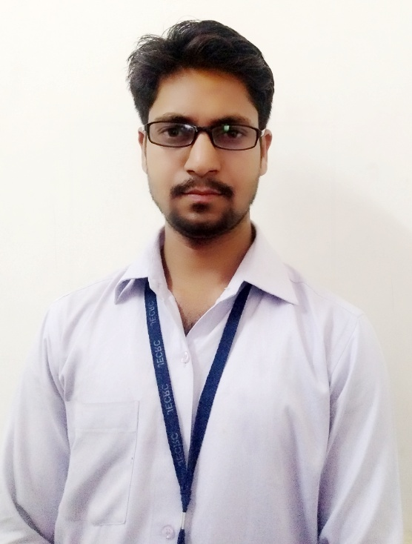

INDIVIDUAL FACULTY DATA SHEET
Name of the faculty member | : | Yogesh Kumar Agarwal
Present Designation | : | AP
Email Id: yogesh.ce@jecrc.ac.in
Contact Details: 9261390542

I. Particulars of Educational Qualification: (only completed)

Category | Name of the Degree | Specialization | Year of Passing | Name of the College | Name of the University
UG | B.TECH | CIVIL ENGINEERING | 2014 | BMIT, JAIPUR | RTU,KOTA
PG | M.TECH | STRUCTURAL ENGINEERING | 2017 | RCERT, JAIPUR | RTU,KOTA
Ph.D.

II. Academic Experience : 3 year

III. Industrial Experience :1 year

IV. Title of Ph.D. Thesis :NIL

V. Awards/Achievements : IAESTE LC JECRC

VI. Research/Specialization : STRUCTURAL ENGINEERING

VII. Course Taught : M.Tech, B.Tech, Diploma

VIII. Refereed International Journal Publication : IJERT

IX. National Conference Proceeding :NIL

X. Books Written : NIL

XI. M.Tech Thesis Guide : NIL
XII. PHD Thesis Guide :NIL

XIII. Professional Body Membership :

